1.40: Using Equations (1.8) and (1.9), the magnitude and direction of each of the given vectors is:

a) 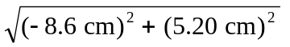 = 10.0 cm, arctan 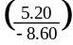 = 148.8º (which is 180º – 31.2º).

b) 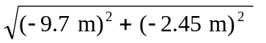= 10.0 m, arctan 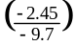 = 14º + 180º = 194º.

c) 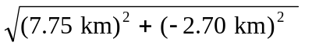= 8.21 km, arctan 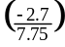 = 340.8º (which is 360º – 19.2º).

